Electronic- Custom Managemnt system



eCms e-Services - Front-End
User Guide

Version: 1.0
Date: 20/04/2022

About CrimsonLogic

CrimsonLogic Pte Ltd delivers world-class eGovernment solutions by leveraging on best-practice technologies, quality human capital and global experiences. Our proven track record of end-to-end eGovernment solutions spans across trade facilitation and customs, judiciary, tax, healthcare, and IT security domains. With 20 years of experience in developing and managing nationwide, mission-critical IT systems and services in a Public-Private Partnership model, CrimsonLogic has set industry standards with world-first eGovernment solutions such as TradeNet, eStamping, eJudiciary and CertOfOrigin. For more information, visit www.crimsonlogic.com

About Yang Khor Pvt Ltd

Yang Khor IT Solutions is a leading In-country Technology Solutions Provider providing solution in terms of hardware, software, support and services as its complete package.
Yang Khor IT Solutions has been serving its purpose since 2005, it now has emerged to be unprecedented leader as a Solution Integrator with a differentiated vertical approach providing innovative solutions. Yang Khor uses its solution integration capabilities to integrate best of breed products through its key technology alliance partners to provide “End to End” solutions. Provide customized business solutions that help organizations accelerate revenue growth, increase market penetration, optimize operating costs and improve employee productivity, by embedding communication in their business processes.

Yang Khor IT Solutions has achieved to be the Gold Partner of HPE, Service One Partner of HPE, Microsoft Silver Partner and VMWARE Professional Partner and having this Partnership we are able to serve the best of solution to our clients. Yang Khor IT Solution initially focuses on providing the best solution in terms of hardware and software, to serve the purpose of making life better with the Advance Technology which the world is moving forward with.

Document History

S.No | Date | Version. No | Description | Approved By
1 |  | 1.0 | First Release
2

Contents
Chapter 1- About this Guide 5
Purpose and Audience 5
Document Conventions 5
Chapter 2- Getting Started 6
A. OTP based Authentication for Registration 6
B. Registration for FE Users: 8
i. Trader Registration: 8
ii. CFA Registration: 12
iii. Bonded Warehouse Operator (BWH) Registration 17
iv. Temporary Storage Operator (TSO) 21
C. Logging in to eCMS 25
D. Reset Password 26
E. Logout of the FE Users: 28

Chapter 1- About this Guide
Welcome to the Electronic Customs Management System (e-CMS) user guide for Registration of Frontend user: Trader, Clearing and Forwarding Agents (CFA), Bonded Warehouse Operators (BWH), Temporary Storage Operator (TSO). This user guide aims to enumerate the process and steps involved in using e-CMS.
This user guide is divided into different topics and sub-topics. Each topic discusses and shows the steps of the modules that the Frontend user can do in e-CMS.

Purpose and Audience
This user guide will help the user to get a quick reference on usage of the system.

Document Conventions
Refer to this section to familiarise yourself with the visual aids used throughout the user guide.
Navigation
To assist you with accessing screens, pages, or windows, refer to the following navigation format:
Click User Registration>>Users
Buttons, fields, and other system elements
All system elements are highlighted in Bold text.
Hyperlinks
All topics mentioned in the user guide’s content are hyperlinked. Click on the hyperlink to view the referenced topic.
Callouts
Callouts are presented differently from the original CONTENTS and highlight certain information.
There are two types of callouts: tips and warnings.
@ | A Tip provides useful information that helps you complete a task or procedure.

! | A Warning refers to information that may be critical to the system’s functionality and might affect data or system stability.

Chapter 2- Getting Started
Refer to this chapter to familiarize yourself with the following:
- OTP based Authentication for Registration
- e-CMS FE Registration, how to register into the system as Trader, CFA, BWH, TSO.
- Different task performed by the FE user.

OTP based Authentication for Registration
The OTP based verification will ensure that the user who is applying for registration of a TPN in eCMS is a valid and authorized user. eCMS will send an OTP to the registered mobile or email of the TPN as available in eCMS TPN Master through RAMIS/BITS integration. Once the OTP is validated in eCMS, system will consider the user as valid and allow the user to register in eCMS (Please refer to Registration SRS for the various types of Registration).
For registration purpose, we will need to first go into the OTP based authentication where in you will be allowed to key in your TPN, registered email address and phone number to receive the OTP for authentication as in the process below:
To get into the authentication the users are to key in the url: https://uat.ecms.gov.bt/ECMSFE/login/indexBhutan.jspl and then Click on Registration as highlighted below:
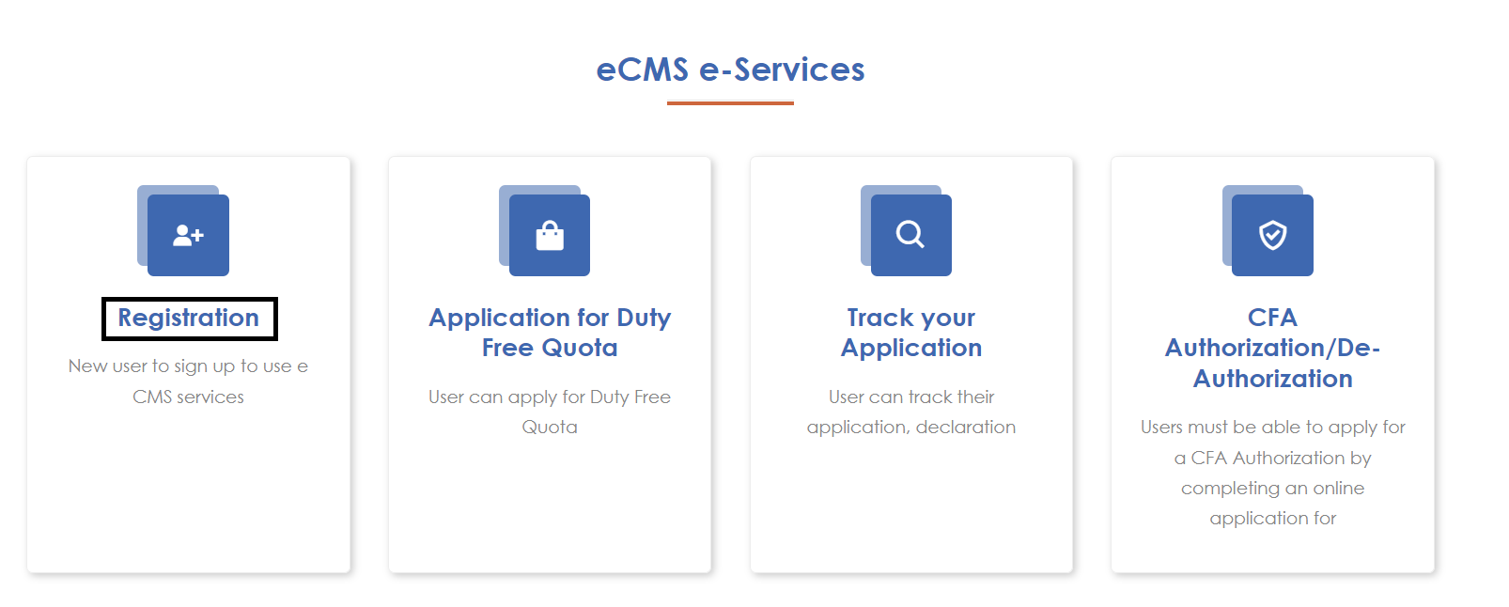
Figure 1.home screen
Step 1: User clicks on the Registration link in the eCMS Portal. System will navigate to OTP Authentication page.
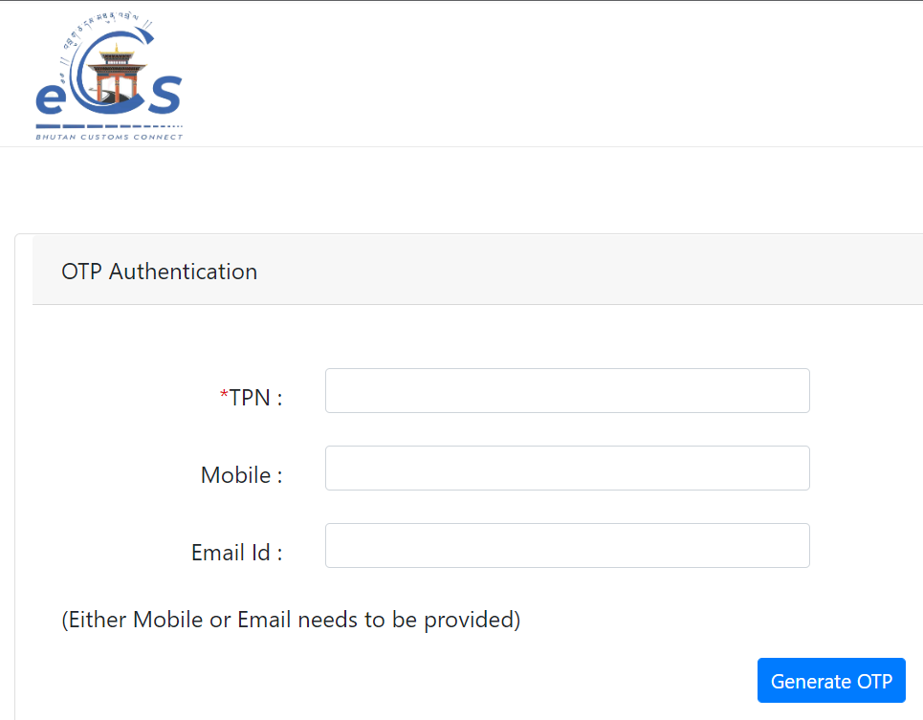
Figure 2.OTP Authentication Screen 1
Step 2: User provides necessary details and clicks on Generate OTP. System validates and sends OTP to the user. After successful sending of OTP, system enables the OTP entry for the user. User will need to key in the OTP received from eCMS to the registered email or the phone number and click on Validate OTP.
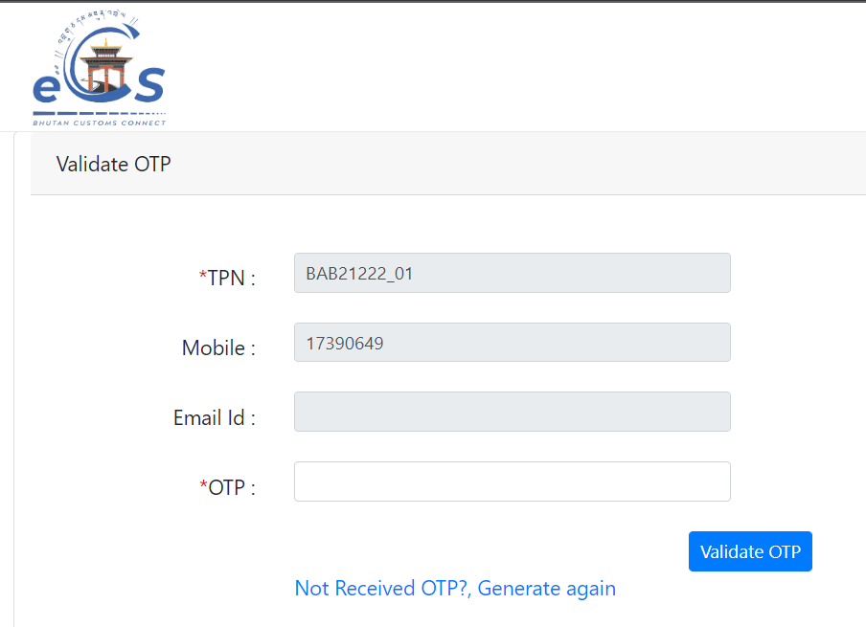
Figure 3.OPT Authentication Screen 2
Step 3: System will validate the OTP and, if it is found to be correct, it will allow the user to proceed with Registration.
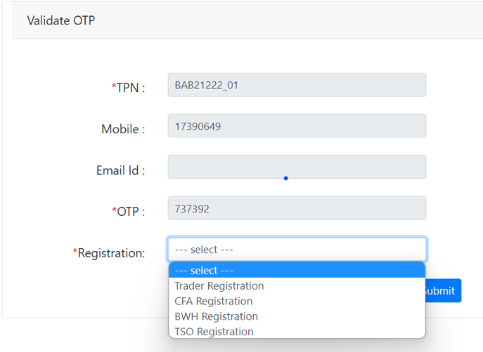
Figure 4.Registration List

Registration for FE Users:
To register into e-CMS:
After the OTP authentication is completed, the user can then select the user they want to register into as shown in the Figure 4. The individual user can register themselves as the following:
You can choose the option from the list for registration:
Field/Button description | Action/Input Required
Trader | Trader can register to get access to eCMS
Clearing & Forwarding Agents (CFA) | CFA can register to get access to eCMS
Bonded Warehouse Operator (BWH) | BWH can register to get access to eCMS
Temporary Storage Operator (TSO) | TSO can register to get access to eCMS

@ | For the user to register as Trader, CFA, BWH and TSO, they should have a valid TPN

Trader Registration:

Click >>Trader Registration
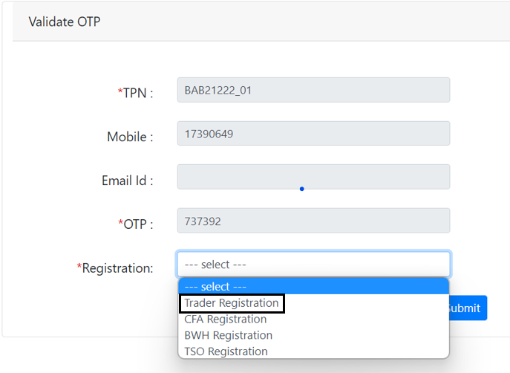

The subsequent screen will be displayed:

- Party Details:
Input TPN Number
The system will validate if the TPN Number is PIT – The filed to add in the CID number will be appeared and if you select BIT & CIT – the filed to add in the Trade License number will be appeared.
TPN number if for PIT, the below screen shall be shown:
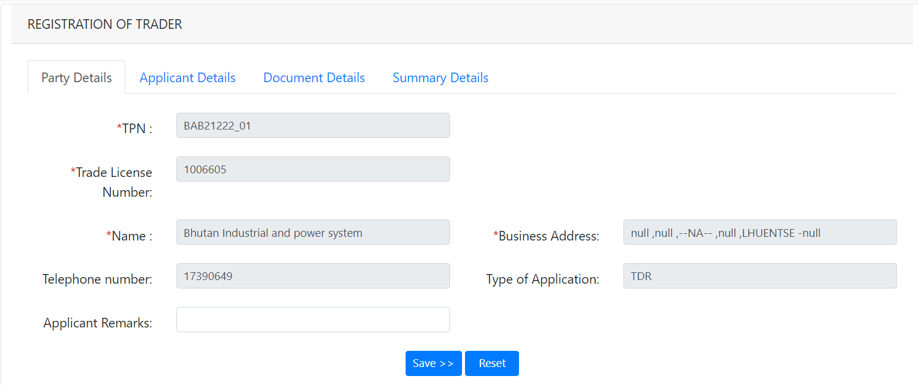
Figure 6.Trader Party details
Field/Button description | Action/Input Required
TPN | Taxpayer number that is received from the DRC
Trade License Number | Trader LIC no if the TPN is of type BIT & CIT
Name | Name of the user is fetched from the TPN Master which was registered with Custom Office
Business Address | Address of the register trader
Telephone number | Contact details of the applicant
Type of Application | The type of the applicant will be shown
Applicant Remarks | Remark if any should be provided here

- Application Details: general information of an individual.
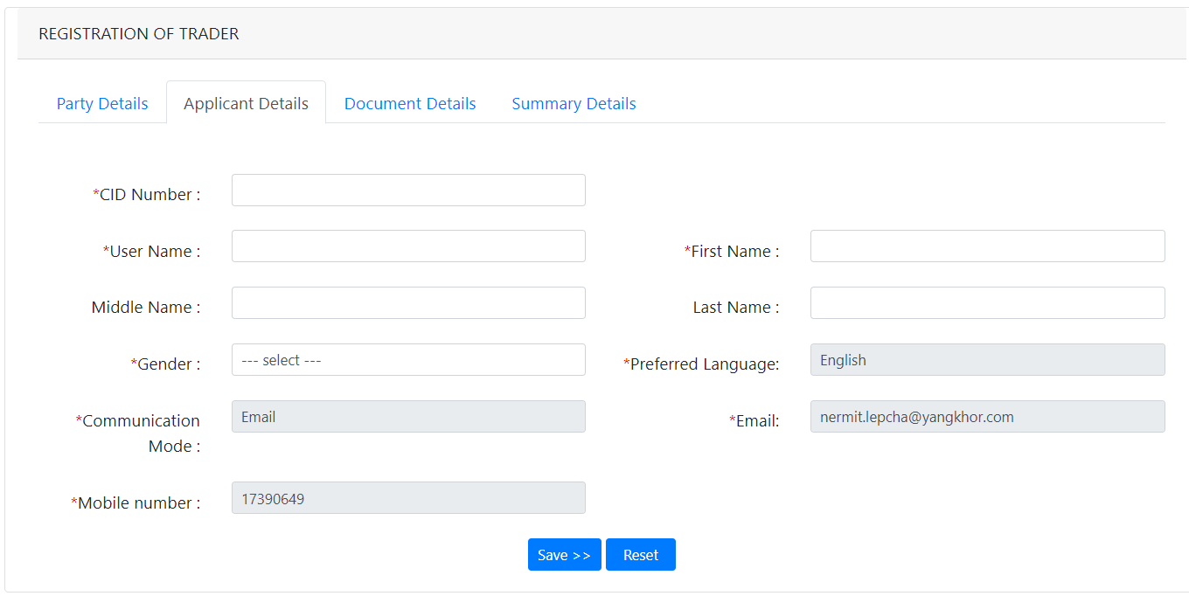

Field/Button description | Action/Input Required
CID Number | Provide your CID number
Login ID | Login id that you want to provide (this will be used later for logging in
First Name | Name of the Applicant
Middle Name | Middle name if any shall be provided
Last Name | Last name of the Applicant
Gender | Gender of the applicant
Preferred Language | What language you prefer can be shown here , as this has been filled at the TPN master creation time
Communication Mode | Mode the applicant wishes to get information on
Email | The applicant email, which will be used by the applicant and custom for communication
Mobile number | Mobile nos of the applicant

- Document Details
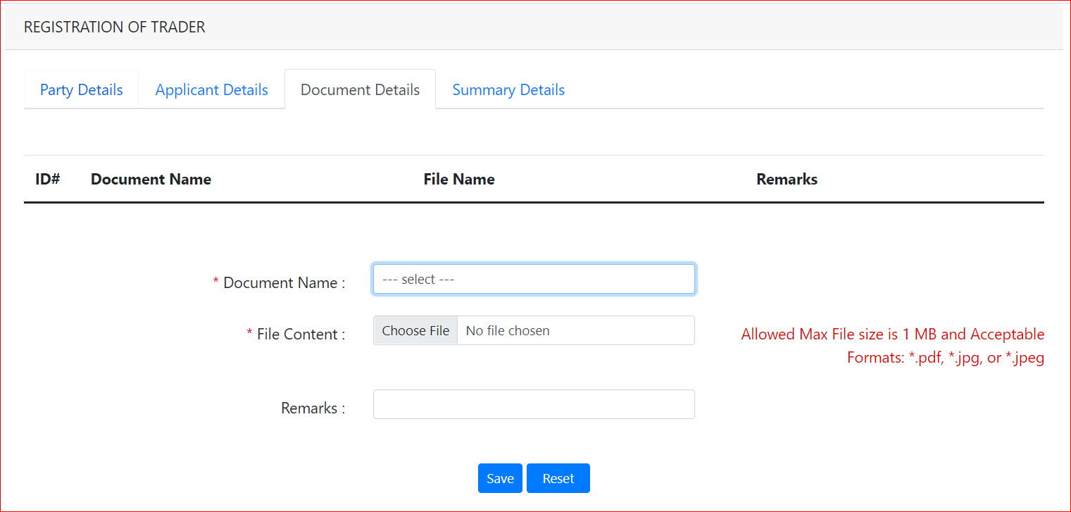

Field/Button description | Action/Input Required
Document Name | List of documents that needs to be uploaded will be listed , the applicant needs to select from the list and upload the same accordingly
File Content | Choose file to be attached
Remarks | Remarks if any should be provided

@ | For now, the trader has no documents to be uploaded.

- Summary Details and Submit
Summary details provides the view of certain details filled in by the user and the user need to tick the acknowledge and submit the same. Once submitted Registration number will be genetrated which shall be used to get the status.
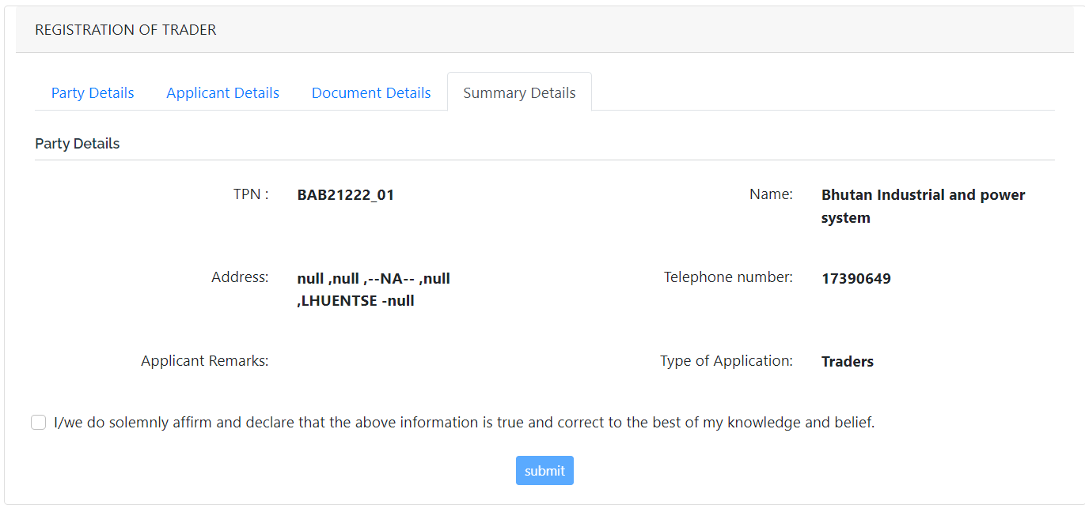

Click Submit >> The application is submitted, and Reg No is provided to you for tracking

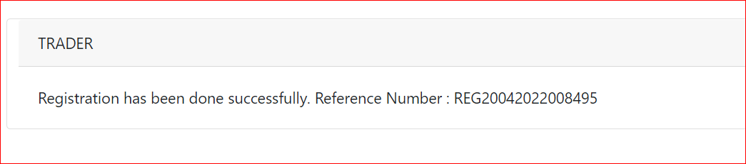

CFA Registration:
Click >>CFA Registration
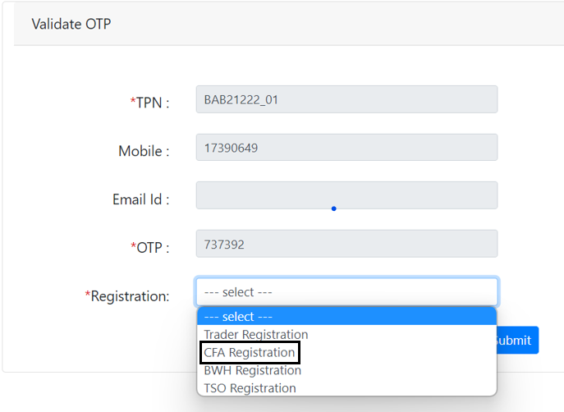

The subsequent screen will be displayed:

- Party Details:

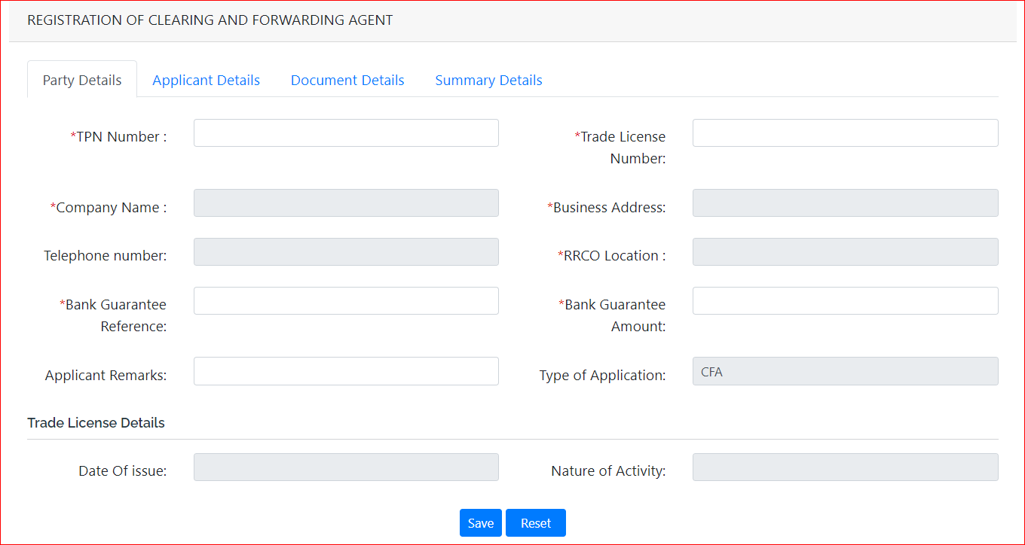
Field/Button description | Action/Input Required
TPN Number | Trader TPN Number
Trade License Number | Trader LIC no
Company Name | Name of the user is fetched from the TPN Master which was registered with Custom Office
Business Address | Address of the register trader
Telephone number | Contact details of the applicant
RRCO Location | Choose the RRCO the applicant belongs to
Bank Guarantee Reference | The type of the applicant will be shown
Bank Guarantee Amount | The amount that was paid in the form of Bank Guarantee
Applicant Remarks | Remark if any should be provided here
Type of Application | Give you the view of type: trade, CFA, WHO and TSO
Trade License details | Date of Issue: | Issue date provided in the License
 | Nature of Activity: | What’s the license for should be mentioned

- Application Details:
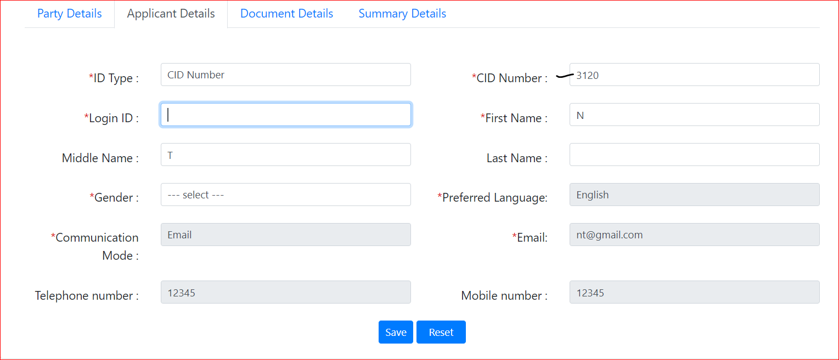

Field/Button description | Action/Input Required
ID Type | CID Number
CID Number | The CID number that belongs to the registered user
Login ID | Id that you wish to keep when you get your registration approved – username to login to the system
First Name | Your first name
Middle Name | Your middle name if you have
Last Name | Your last name
Gender | Your gender
Preferred Language | Language you would like to work in  note: currently we have English as the preferred language
Communication Mode | Phone or mail which way you wish the notification and import new to be given to you
Email | If you choose email- give your mail, if phone then your mobile number
Telephone number | Add in your company phone if any
Mobile number | Your mobile number

- Document Details 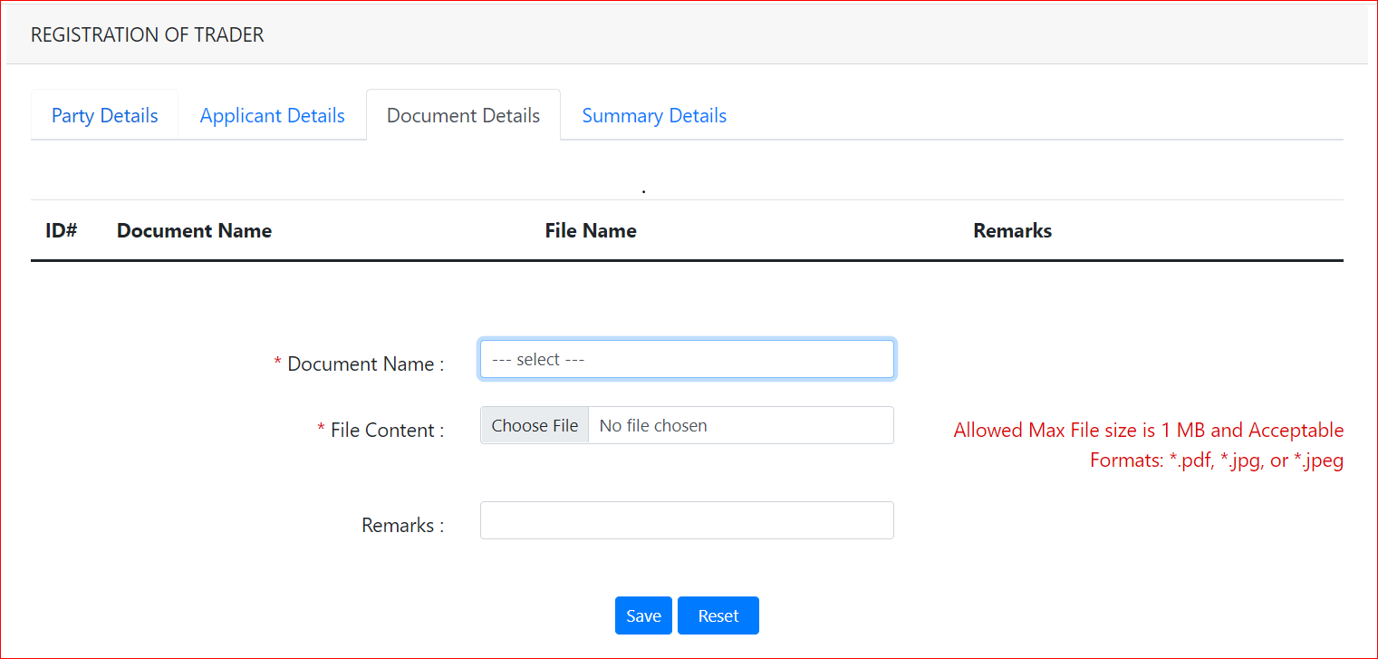

Field/Button description | Action/Input Required
Document code | List of documents that needs to be uploaded will be listed
File Content | Choose file to be attached
Remarks | Remarks if any should be provided

@ | For CFA – three different documents are to be uploaded when registration

- Summary Details and Submit

This will give the preview of the details one filled for registration, as shown below:
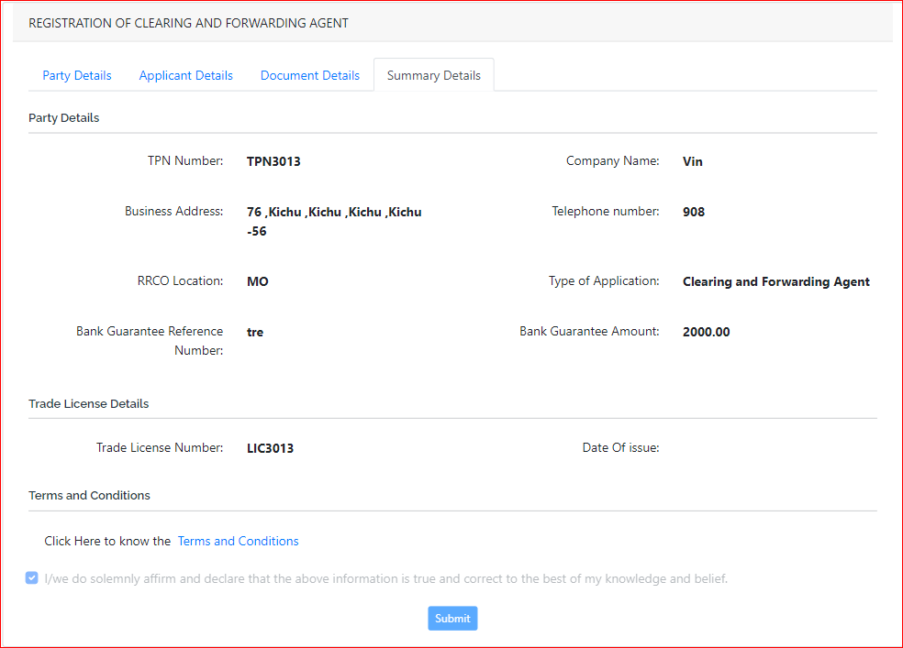
@ | For CFA – they need to agree to the Terms and Condition by clicking into it and then submit

Click Submit >> The application is submitted, and Reg No is provided to you for tracking

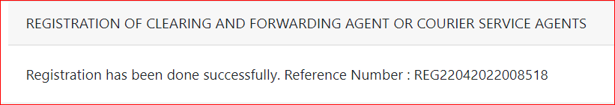

Bonded Warehouse Operator (BWH) Registration
Click >> BWH Registration
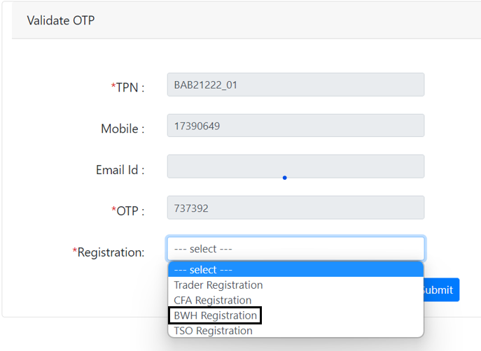

The subsequent screen will be displayed:

- Party Details:

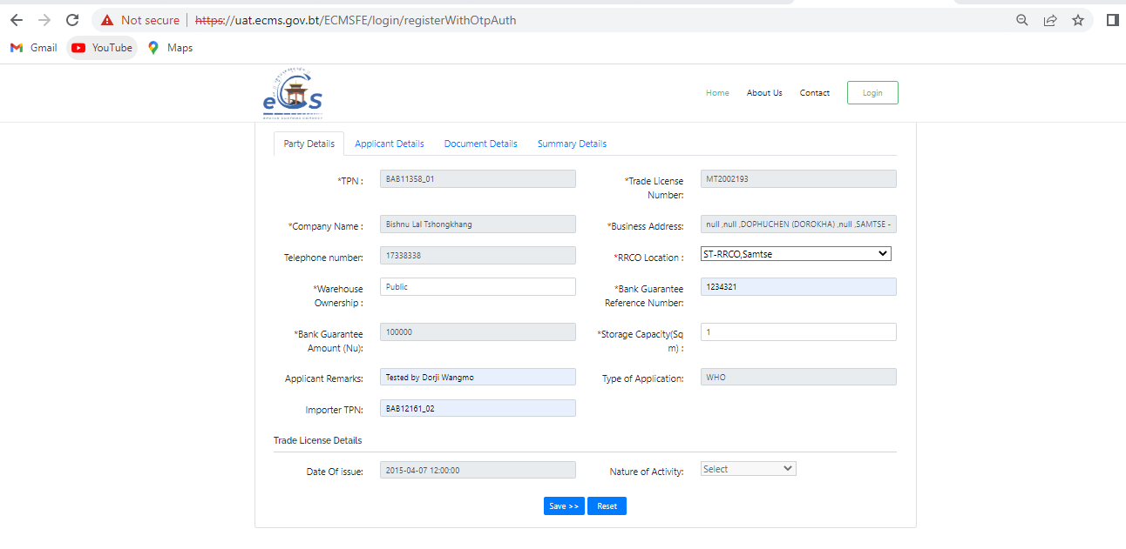

Field/Button description | Action/Input Required
TPN Number | Trader TPN Number
Trade License Number | Trader LIC no
Company Name | Name of the user is fetched from the TPN Master which was registered with Custom Office
Business Address | Address of the register trader
Telephone number | Contact details of the applicant
RRCO Location | Location of the register
Bank Guarantee Reference | Reference number of the bank guarantee
Bank Guarantee Amount | The amount that is there in the bank guarantee
Warehouse ownership | Here we need to select from two type: Public or Private
Storage Capacity | Capacity of the warehouse
Applicant Remarks | Remark if any should be provided here
Type of Application | The type of the applicant will be shown
Trade License details | Date of Issue: | License date
 | Nature of Activity: | Activity of the license holder and register

- Application Details:
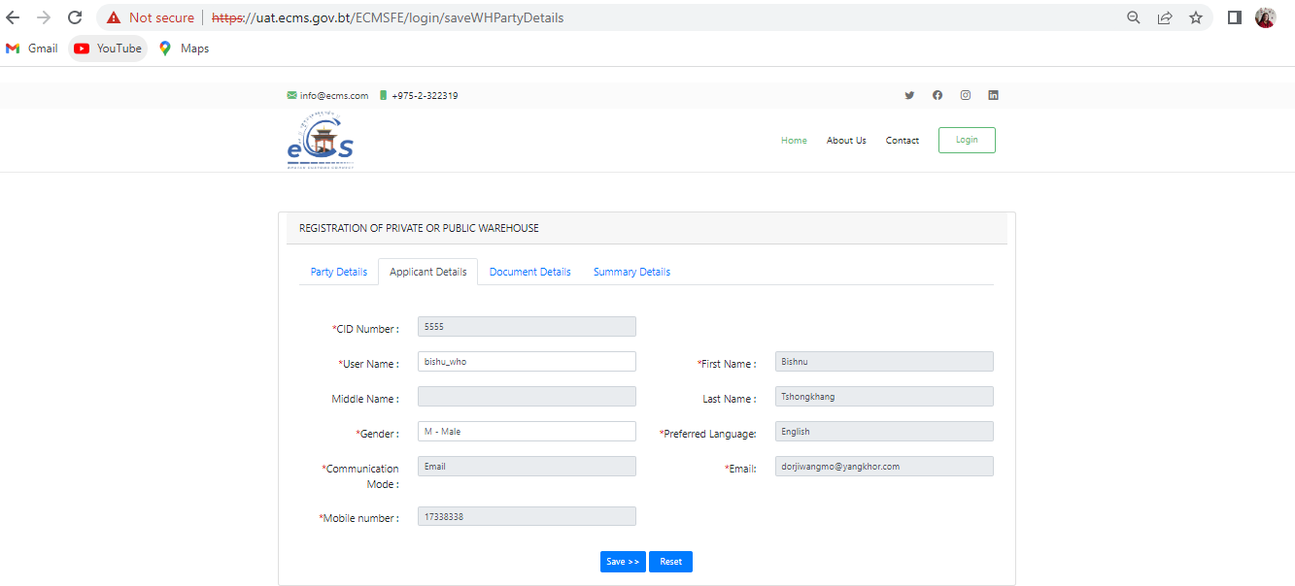

Field/Button description | Action/Input Required
CID Number | The CID number that belongs to the registered user
Username | Id that you wish to keep when you get your registration approved – username to login to the system
First Name | Your first name
Middle Name | Your middle name if you have
Last Name | Your last name
Gender | Your gender
Preferred Language | Language you would like to work in  note: currently we have English as the preferred language
Communication Mode | Phone or mail which way you wish the notification and import new to be given to you
Email | If you choose email- give your mail. If phone then your mobile number
Mobile number | Your mobile number

- Document Details


Field/Button description | Action/Input Required
Document code | List of documents that needs to be uploaded will be listed, here for BWH need to upload Bank Guarantee
File Content | Choose file to be attached from your system
Remarks | Remarks if any should be provided

@ | For BWH –need to upload BG  File to be uploaded should be of max size 1 MB and formats: pdf, jpg or jpeg

- Summary Details and Submit

This will give the preview of the details one filled for registration, as shown below:
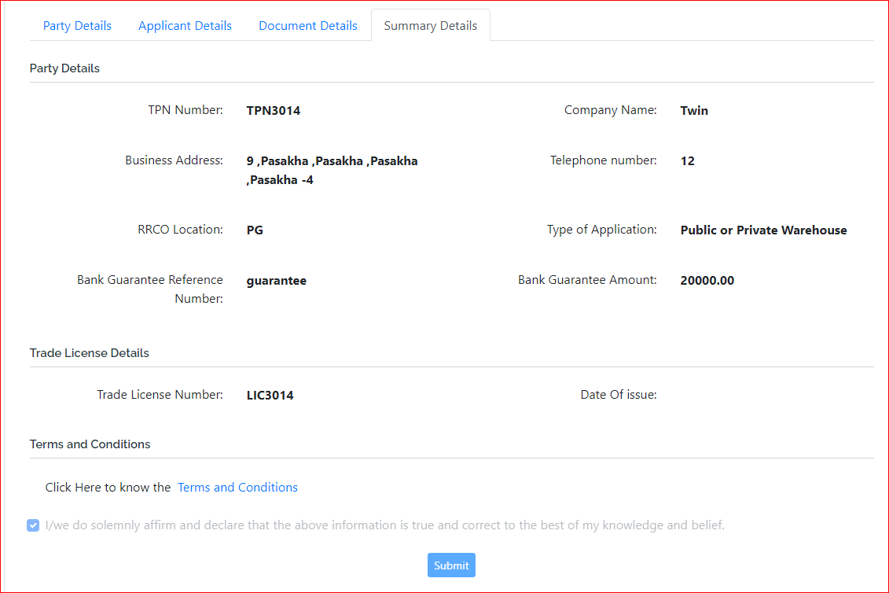
@ | For BWH – they need to agree to the Terms and Condition by clicking into it.

Click Submit >> The application is submitted, and Reg No is provided to you for tracking

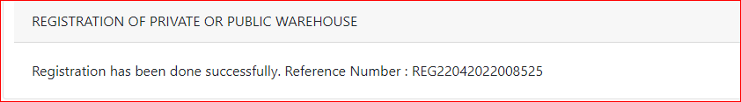

Temporary Storage Operator (TSO)
Click >> TSO Registration
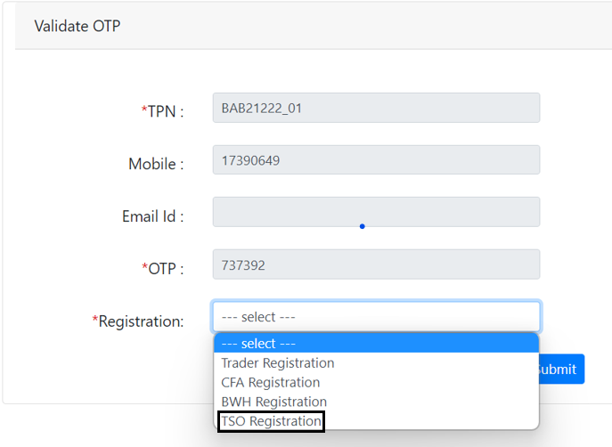

The subsequent screen will be displayed:

- Party Details:
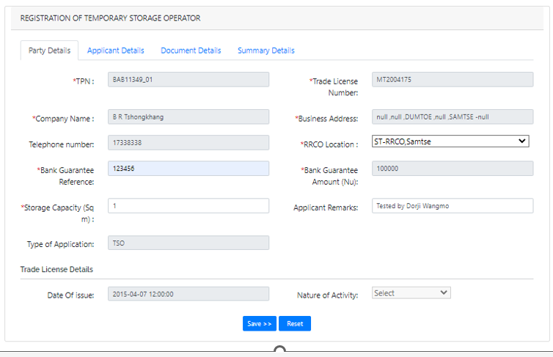

Field/Button description
TPN Number | Trader TPN Number
Trade License Number | Trader LIC no
Company Name | Name of the user is fetched from the TPN Master which was registered with Custom Office
Business Address | Address of the register trader
Telephone number | Contact details of the applicant
RRCO Location | Location of the register
Bank Guarantee Reference | Reference number of the bank guarantee
Bank Guarantee Amount | The amount that is there in the bank guarantee
Storage Capacity | Capacity of the warehouse
Applicant Remarks | Remark if any should be provided here
Type of Application | The type of the applicant will be shown
Trade License details | Date of Issue: | License date
 | Nature of Activity: | Activity of the license holder and register

- Application Details:
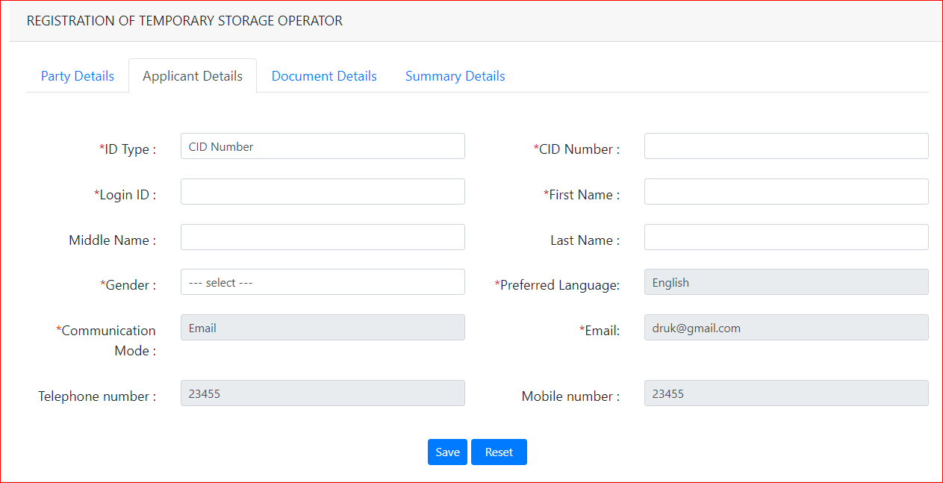

Field/Button description | Action/Input Required
ID Type | CID Number
CID Number | The CID number that belongs to the registered user
Login ID | Id that you wish to keep when you get your registration approved – username to login to the system
First Name | Your first name
Middle Name | Your middle name if you have
Last Name | Your last name
Gender | Your gender
Preferred Language | Language you would like to work in  note: currently we have English as the preferred language
Communication Mode | Phone or mail which way you wish the notification and import new to be given to you
Email | If you choose email- give your mail. If phone, then your mobile number
Telephone number | Add in your company phone if any
Mobile number | Your mobile number

- Document Details


Field/Button description | Action/Input Required
Document code | List of documents that needs to be uploaded will be listed, here for BWH need to upload Bank Guarantee
File Content | Choose file to be attached from your system
Remarks | Remarks if any should be provided

@ | For BWH –need to upload BG  File to be uploaded should be of max size 1 MB and formats: pdf, jpg or jpeg

- Summary Details and Submit

This will give the preview of the details one filled for registration, as shown below:
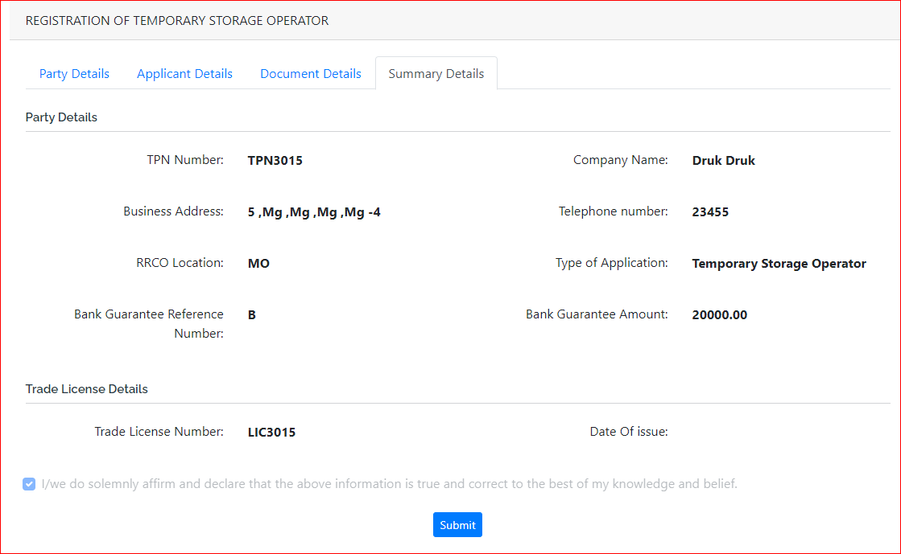
Click Submit >> The application is submitted, and Reg No is provided to you for tracking

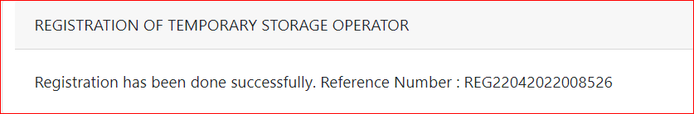

Note: Approval process is done by Custom Officer, once approval is done the user will receive the mail with username and default password

Password send to the provided registered mail id as shown below:
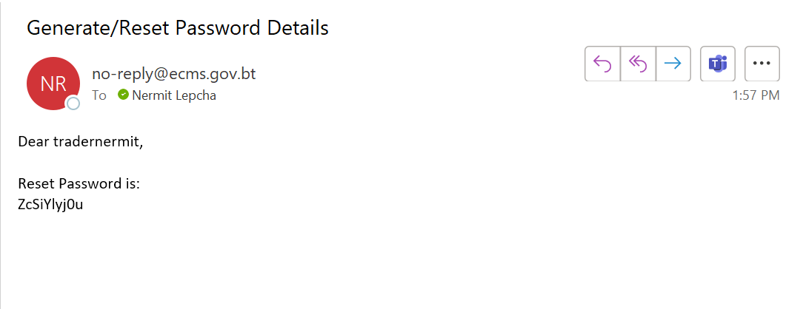

Logging in to eCMS
After the registration is completed, the individual will be provided with the login credentials username and default password, which will be asked to set while login for the first. Once completed the user can login to the portal and perform the task associated.

To login to the e-CMS FE:

- Type in URL: https://uat.ecms.gov.bt/ECMSFE/login/indexBhutan.jsp in your Internet browser to access the e-CMS.
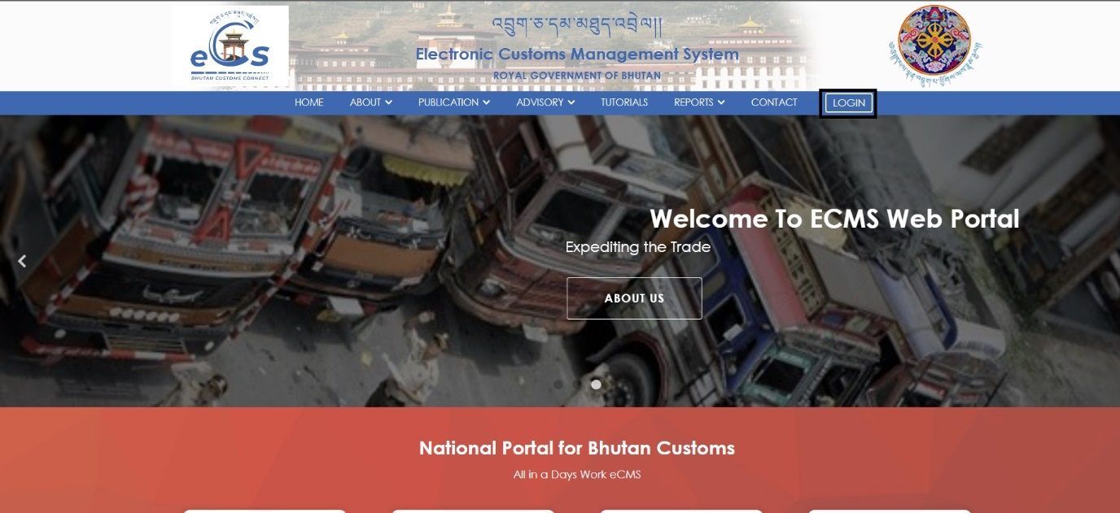

- Click on the Login you will be taken to the page to key in your username and password:
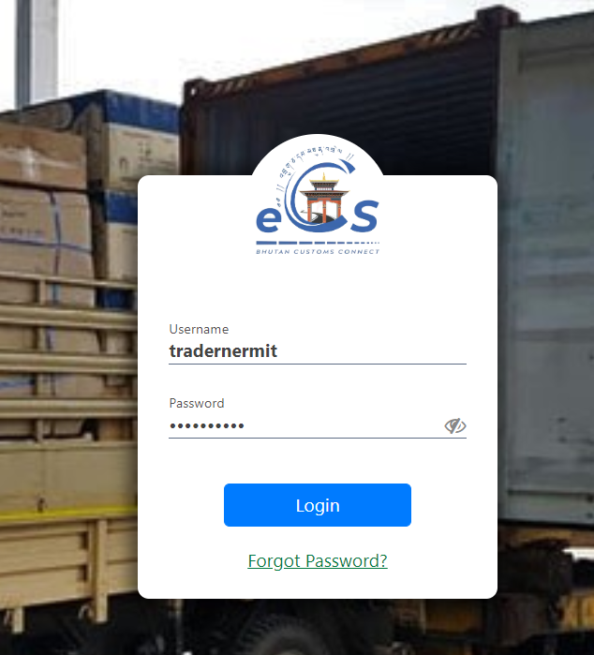

- Input the username and password that was created for the individual. (Trader, CFA, BWH, TSO), upon login with default the user will be asked to provide their own password for further use.
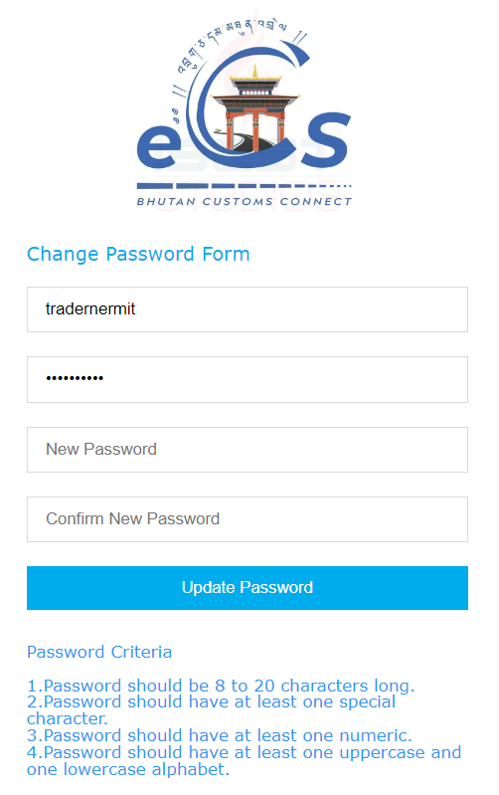
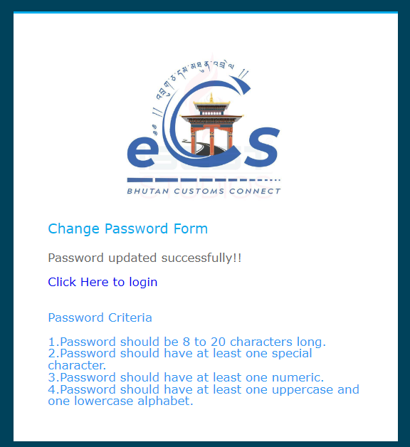

- After the process is done the user will be allowed to login with the password set by them self. For that click on Click Here to login
- After login in the user will be seeing their individual dashboard with various menu to perform different task.

Reset Password
User has the reset the password if they forget the password or want to change the password by selecting the Forgot Password.
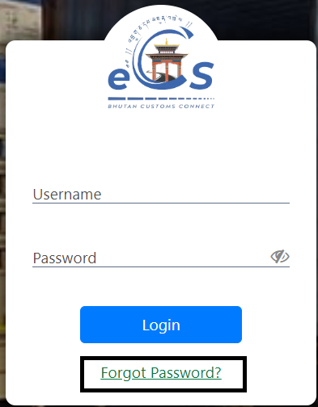

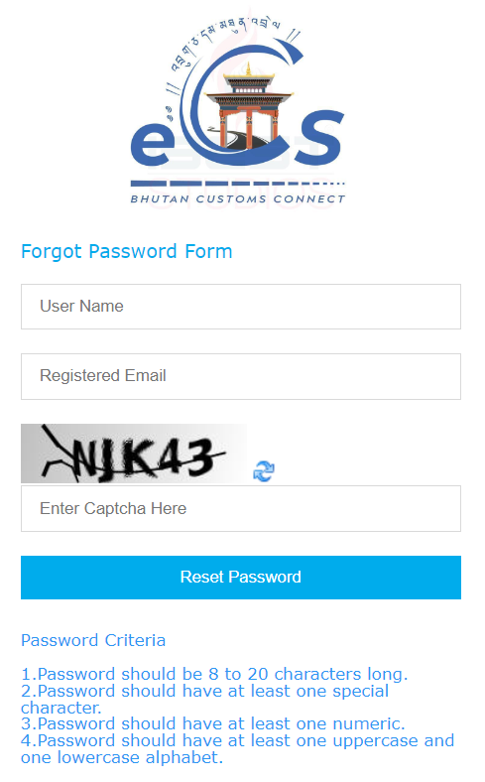
After the forget password has been clicked, the user will be asked to key in the registered mail so that the default password will be send to the mail then taking that the user will be to key in the new password.

Once login the user will be allowed to view the dashboard having the modules that is relevant to them.

The individual user will be able to view their dashboard with data related to them. The screen will be different for all the user (Trader, CFA, BWH, TSO)

Logout of the FE Users:
This function allows the user to log out from the application any time. User can sign out from the eCMS any time by simply clicking the button available at the upper right corner of the user logged-in window.

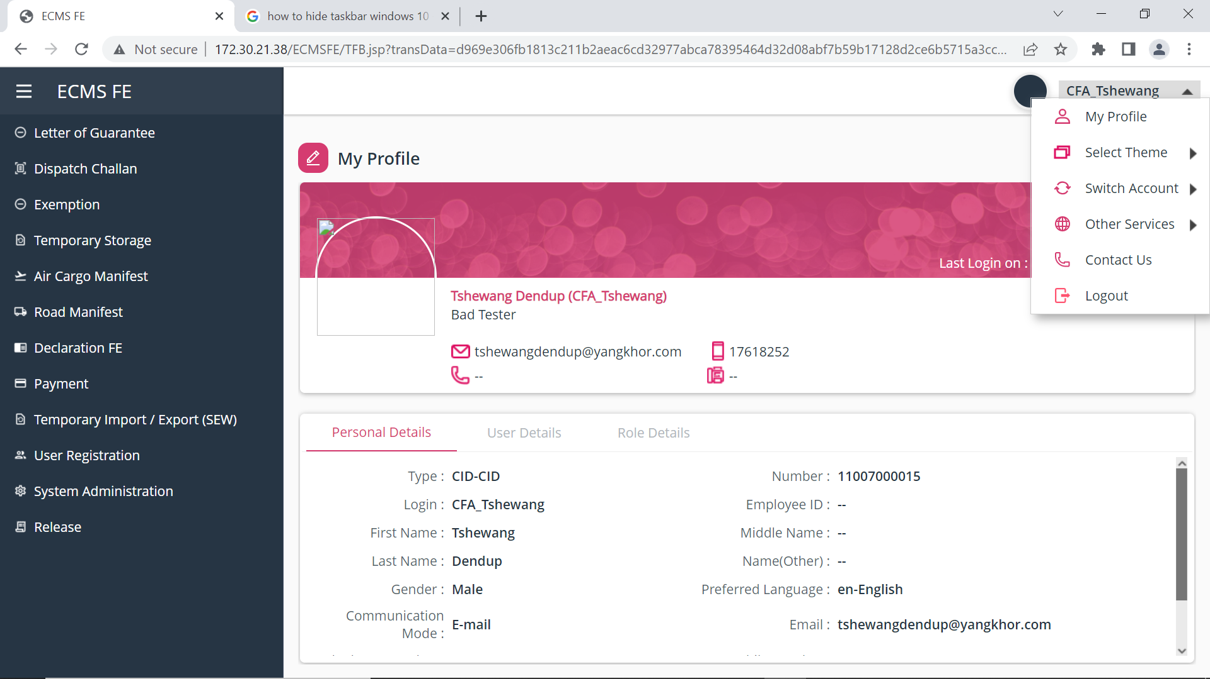
Log Out Page

